Project 3 Reflection

Richard Gray CMST 385

**a. What is the URL of your assignment?**

<https://cmst385-rgray68.azurewebsites.net/project3/index.html>

**b. What issues or challenges did you face completing this project?**

The main issues I faced were around CSS styling. I used a combination of Grid and flex to get the items to align, but some still didn’t align properly, or were missing completely, such as the footer on the music page.

**c. What software programs did you use to create this project?**

I used figma for the planning of the site design, which I wanted to be low fidelity to match Charli XCX’s current album aesthetic. I also used VSCode for the editing and Brave (Chromium) browser to view the webpages.

**d. Where did you get your images from?**

Artist photo (from press assets, edited to remove background, compressed to less than 100kB, added hard-light mix blend mode to blend into background.)  
<https://www.dropbox.com/sh/3cs8464vcj0vi7g/AAAY9mYZrZYXv9ZC201vCguLa?dl=0&e=1&preview=Charli+XCX+%5BCredit+-+Harley+Weir%5D.jpg>

Album art:

How I’m Feeling Now: <https://open.spotify.com/album/3a9qH2VEsSiOZvMrjaS0Nu?si=jX4qtjmGSRmo5VnxO-73Ig>

Crash:   
<https://open.spotify.com/album/1QqipMXWzJhr6yfcNKTp8B?si=uEdsvR3ST2ipcN68xxpLFA>

Brat:

<https://open.spotify.com/album/2lIZef4lzdvZkiiCzvPKj7?si=lySH8vLPSvKjulKB7AU9bg>

**e. Include the validation information for your HTML5 and CSS validation you completed for this assignment.**

CSS Validation:

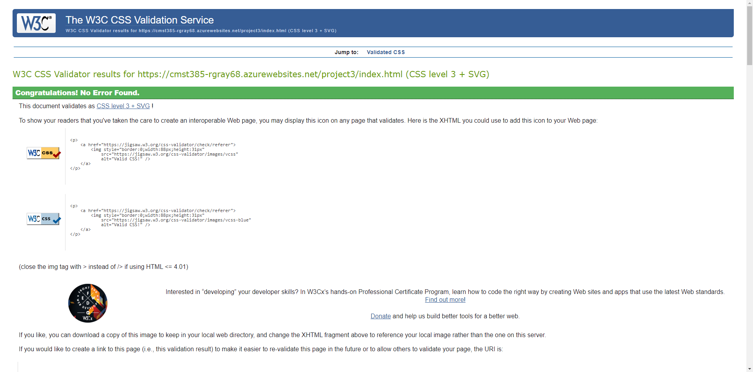

Index.html Validation:

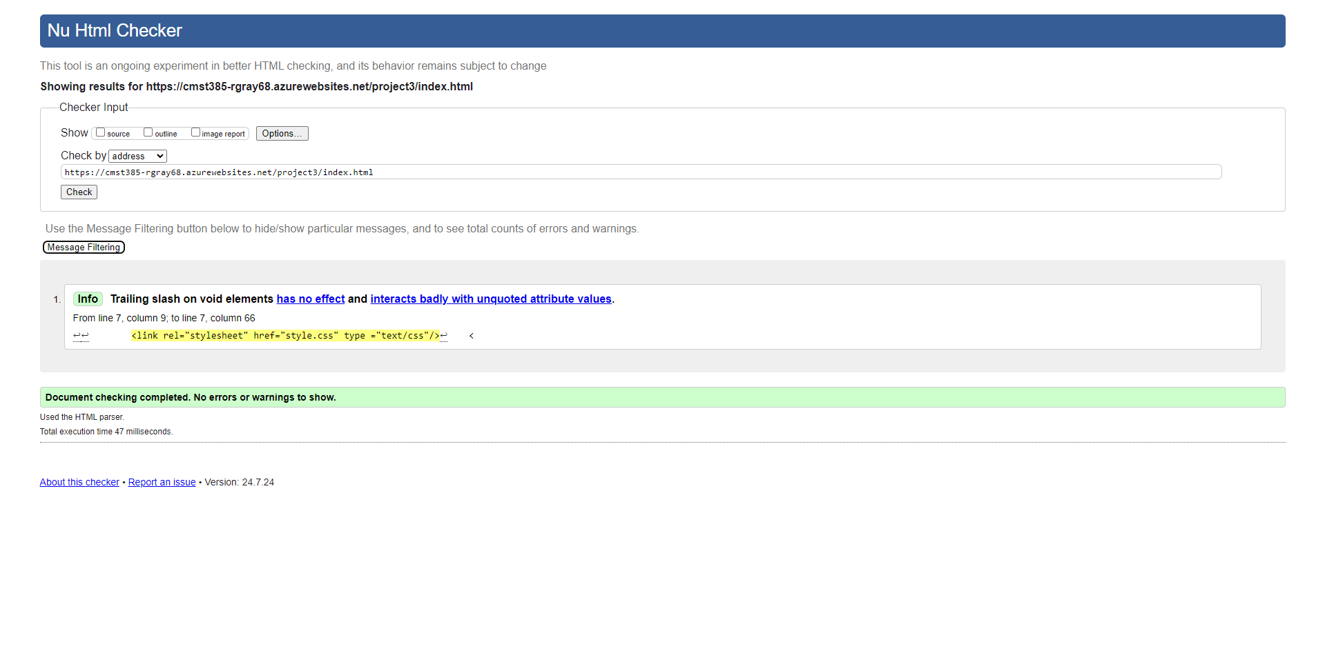

Music.html Validation:

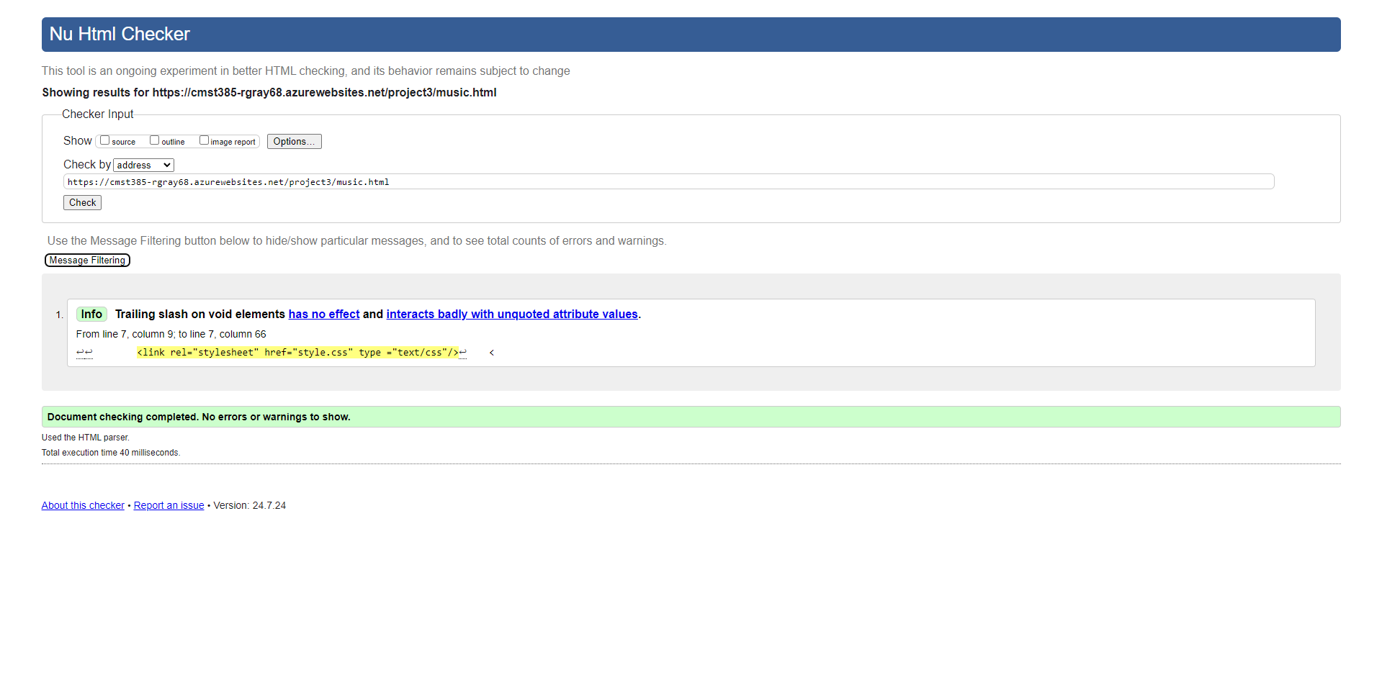

News.html Validation:

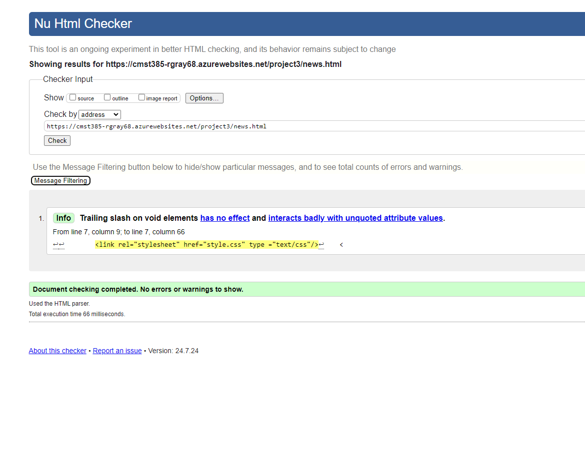

News Article validation:  
